0.0
Using iPSA Styles
The Editors
This style guide is both a description of the MS-Word formatting styles used for position papers, essays, and (finally) articles for Psyche Extended and a template that can be used to copy/paste styles into any new .docx file.
Authors’ contributions to projects in iPSA should not be uniform in every detail, but style coordination of writing in the early stages will help to streamline the process of sharing and dissemination, from early contributions all the way to the “finish line” of publication in iPSA’s on-line journal, Psyche Extended.
Many if not most users of MS-Word are unfamiliar with the use of Styles. Most format as they go, modifying the Normal style manually, changing fonts, font sizes, and position as they type. To get the text to “look right,” the writer too often choses to insert spaces or lines manually. The downside of this is that, to get texts in shape for publication, authors and editors have to undo each and every manual action. Lines and spaces have to be removed one at a time; styles have to be applied, laboriously. Editing sometimes takes more time than the original writing.
Participant-authored works are important in every project. They allow authors to read and critique each other’s works. They allow a broader readership to download and read ongoing research before a project has been concluded. Eventually, these early e-publications lead the way to a final publication, either in the on-line journal or a book proposal; then, to the assembly of files to send to a publisher. The smoother this process, the less the anxiety. Authors and editors can talk about content rather than style.
The basics are this:
- The main font is Minion Pro, 12-point, with lines spaced 1.1 inches. First paragraphs of sections do not indent first lines, but subsequent paragraphs indent first lines by .2 inches. Spelling is mainly American, but UK and Canadian spellings will not be changed. The ligatures in fl and fi look slightly better in Minion Pro than other fonts.
- Paragraphs are separated by 6-point spaces, automatically inserted by the STYLES. Never never never insert lines, to say nothing of spaces, manually. To see what’s happening, turn on the formatting button on the HOME tab (the paragraph symbol, ¶). You will see dots at all spaces and faint ¶ at all line breaks.
- Document numbers, title, author names, and heads are Helvetica Neue, various sizes and spacings. Heads are left justified, the rest are centered.
- Inline citations (Robertson 2002: 41–3) should be rare and used only in concert with bibliographies at the end of the main text; instead, footnotes should be used, using the “insert footnote” command, INSERT>footnote… .
- To separate text — for emphasis or paraphrase — use M-dashes, not N-dashes (–) or, God forbid, hyphens (-). To find out how to use these on your computer, Google and learn. Memorize. M-dashes should have spaces on either side to help the editors.
- Headers, hopefully, should be few and far between. Use “ipsa header” style for all, but convert the Helvetica Neue Bold to non-Bold italic, and take the font size down from 16 point to 14 point. This is one of the few manual jobs you will have to do.
- Footnotes are made by using INSERT> (from the top, main toolbar) footnote… . MS-Word will wish to revert to the “house style,” so you may have to click on FORMAT>style… to make the change to “ipsa notes.” This will change the font size, line spacing, and indentation.
- Don’t forget to “turn on curly quotes” so that you see “word” rather than "word." Check this by clicking on WORD at the upper left corner of the MS-Word window. You will see PREFERENCES. Open that box and select Autocorrect. You should have checked the box next to “straight quotes with smart quotes.” If you need to use straight quotes you can always get them (on a Mac) from the “show Emoji and symbols” button on the main tool bar at top.
- Lists, numbered or bullet-pointed, should be done manually starting out with the main paragraph style, ipsa-first-paragraph or ipsa-next-paragraph, whichever contains the list. This is about the only time we’ll ask you to do something manually.
How to Import, Set up, and Use “Styles”
Use this file for practice. On the Home toolbar tab, look to the far right to see the button labelled “Styles Pane.” Click on it to get a window showing a list of styles, sometime poorly scaled. The aim here is to use the option buttons at the bottom, “Show styles guides.” This will let you see the style used for each part of your writing, a colored bar with a number. You should have a colored bar for every part of your text, it’s just a matter of clicking on the text; the bar will pop up on the left. This option, plus the formatting button, ¶, will be your best friend when you proofread your text. You can “see what’s happening.”

It is important to begin “thinking in terms of styles” rather than manual formatting. Styles allow authors and editors to make changes consistently throughout an entire document with single adjustments, rather than having to change each and every instance. When you click on FORMAT in the upper-most command bar (which sometimes doesn’t appear unless you move the cursor to the top of the frame) and choose style…, you get this window:
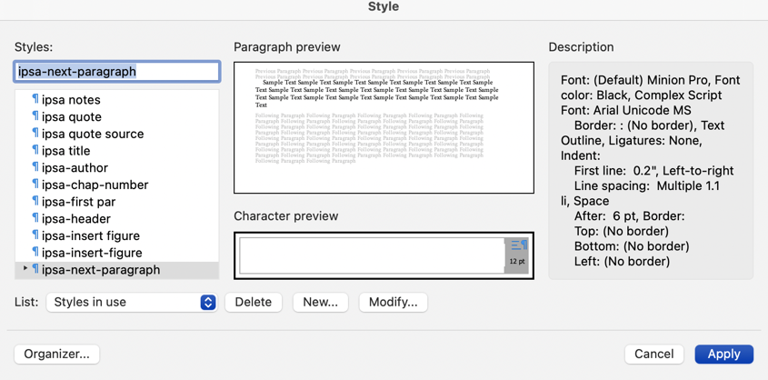
Figure 1. The Style pane that lists “styles in use” — alternatives are “all styles” and “user-defined styles.” Make note of the location of the button on the lower left, “Organizer….” (Aside: To insert a caption below a graphic, use the INSERT tab and select “Text Box.” This will activate your cursor to draw a rectangular text box on the page.) You must remove the border in the Home toolbar ribbon, using the FORMAT SHAPE option. This is tricky! Go to the Shape Format tab, to the far right of Home, Insert, Draw, Design … You will get a box on the far right, with “Format Shape” and “Styles.” Chose the former and click, uner “Text Outline,” NO LINE.” This is way more complicated than it should be.

You should choose Organizer… (lower left) to bring up this text box:
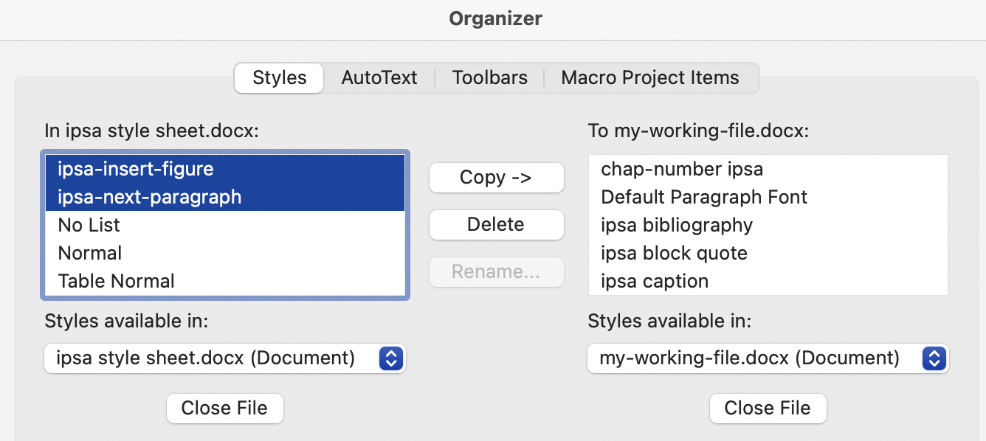
Figure 2. On the left, close the auto-selected files then find and select “ipsa style sheet.docx.” On the right, close the auto-selected file and then locate and chose “my-working-file.docx, meaning, whatever file you are working on. Select all of the styles beginning with “ipsa” on the left and use the Copy -> button to move them into your file.

With all the iPSA styles loaded into your text, you are ready to start writing and editing. At this point you can, mischievously, alter the styles, but editors will change them back when it comes time to prepare documents for uploading or publishing. The point is that, with Styles, changes can be made uniformly and quickly.
Punctuation
[Note: this is a rare case of a subtitle. It is made by formatting the header as a head, then manually altering the font size (down from 16 to 14 points), changing from Bold to Regular, then Italicizing.]
- The British and Continental practice is to use single quotes as the main quote: ‘As we have often noted …’ and placing the punctuation outside of the quote marks: ‘We conclude our remarks’. OURS IS AMERICAN STYLE: “As we have often noted …” with the punctuation INSIDE the double or single quotes: “We conclude our remarks.” Along with using curly quotes, this is the one set of rules you must internalize, to save editors from losing years off their lives.
- M-dashes (—) are used to separate text that is supplementary. N-dashes (–) are used mainly to indicate spans in page numbers (143–47) — note the abbreviation of the second number, with the exception that years are written out (1947–1952). Hyphens are used to separate compound words or names (oft-imagined, Spencer-Brown). Do not substitute two hyphens for an M-dash (--). Remember to space the M-dash — for reasons we shouldn’t have to mention — rather than the more common—in publishing at least—unspaced separator. The spaced M-dash is easily converted to the un-spaced version if some publisher demand.
Referencing in Footnotes and the Bibliography
iPSA did not choose a referencing style randomly. The Chicago Manual of Style is easy to use, examples abound on the (free) internet, and this famous handbook is notoriously complete. For most of our uses, footnote style and bibliographic style are different. Footnote style looks very familiar, since it is often used for everything.
Jacques Lacan, The Language of the Self: The Function of Language in Psycoanalysis, trans. Anthony Wilden (Baltimore: The Johns Hopkins Press, 1968), 133–36.
The Bibliographic Entry would look like this:
Lacan, Jacques. The Language of the Self: The Function of Language in Psycoanalysis. Translated by Anthony Wilden. Baltimore: The Johns Hopkins Press.
Of course, there are many different types of sources, requiring many different rules of punctuation, style, and other conventions. It is impossible to list all of them in this style sheet, which is why we chose the Chicago Manual of Style as our main guide. For a quick guide, go to https://www.chicagomanualofstyle.org/tools_citationguide/citation-guide-1.html. We can show you a few typical cases:
- Sources cited in notes from the internet:
³⁵ Jacques Lacan, The Seminar of Jacques Lacan Book IX: Identification, 1964–1965, trans. Cormac Gallagher, Lacan in Ireland; http://www.lacaninireland.com/web/wp-content/uploads/2010/06/Seminar-IX-Amended-Iby-MCL-7.NOV_.20111.pdf. Accessed January 9, 2024.
[Note: hanging indent used in footnotes couldn’t be shown here. Also: for internet addressed, REMOVE THE LINK to reduce the possibility of virus transmission]
- Same source as it should appear in the Bibliography:
Lacan, Jacques. The Seminar of Jacques Lacan Book IX: Identification, 1964–5. Translated by Cormac Gallagher. http://www.lacaninireland.com/web/wp-content/uploads/2010/06/Seminar-IX-Amended-Iby-MCL-7.NOV_.20111.pdf. Accessed January 9, 2024.
- After the first citation, the footnote can be abbreviated:
¹²Lacan, Identification, 132.
- Films and other media:
³ Stanley Kubrick (dir.), 2001: A Space Odyssey [video disk] (Hollywood, CA: Warner Borthers Home Entertainment, 2018). Check Chicago for other types of media.
[Again, hanging indent couldn’t be shown here.]
- Pagination and Lower Margin Header: Use Insert> page numbers; select “lower right.” Change the font to Minion Pro 12-point. With the Lower Margin header still open, type in the standard form: a document number (your author number, and the sequence number of your document, in italics:
2.4 / Ghoochani [translation: Ghoochani is the second author to submit in a series, and this is the fourth document he has submitted]
Illustrations
Graphics are possibly the most difficult components of any document. While generally copyright issues are not critical for web circulation of proprietary materials, publishers require that permissions be obtained far in advance of publication. Publishers who monetize materials are sometimes refused permission to reprint, an issue that extends to extended quotes. At the early stages of document circulation, we recommend that graphics, with labels and captions, be assembled in PowerPoint or Keynote, screen captured into a .jpg file, and placed into the text as a unit. The caption must be scaled to match the text font within a point or two. For pre-publication versions, photos and other .jpg files should be low resolution, generally <200 dpi and <300 kb in size.
Use the Layout tab to set text flow around graphics, either wrapping or flowing from above to below. In the latter case it is permissible to add lines manually to accommodate graphics in relation to the text.

This style sheet is based on the styles used in Lacan+Architecture, hopefully completed and released by Fall 2024. John Shannon Hendrix and Francesco Proto, assisted by Andrew Payne, copy-edited the essays and composed, with Lorens Holm, forward and afterward materials. Don Kunze was responsible for formatting and indexing, in the process teaching himself how to advance (slightly) beyond the beginner’s level of MS-Word formatting. In the Lalangue and Tiny House Projects, editorship will shift to Jodi LaCoe and Cindy Zeiher.
The paragraph symbol (¶) is an example of the rare instances when Minion Pro fails to reproduce a character correctly and the writer must make a manual change. If you click on the symbol you will see that it is Times New Roman.

